Day in the Life of the Hudson River 10/14/21
STEAMBOAT DOCK, VERPLANCK
RIVER MILE: 41
Salt Front: ~ RM 49
Mahopac High School- Scott Rizzo, Trisha Johnson, and Bob Connick
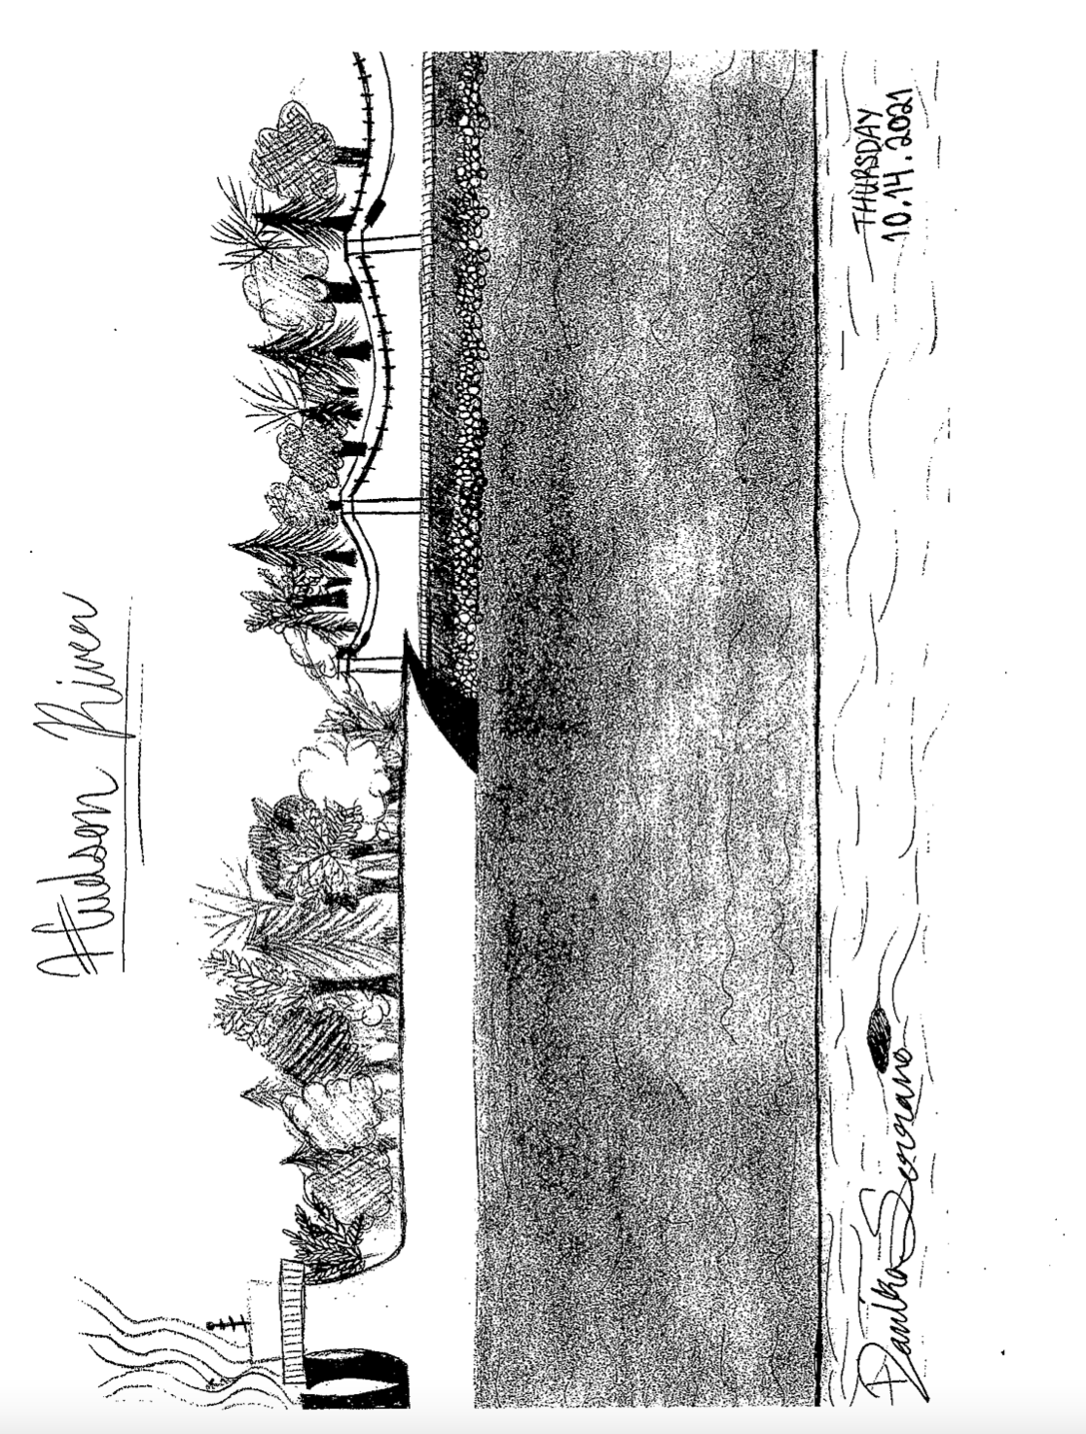
35 students, 9-12th grade
Latitude 41.24936 N & Longitude – 73.936474 W

Location: Steamboat Dock Park beach, City of Verplanck in Westchester County
Area: located in a small cove, parking lot with beach access to the Hudson
Sampling Site: Pier, parking lot, beach, riprap, pipe entering the water
Surrounding Land Use: 30% Urban/Residential, 35% Beach, 35% Parking lot
Shoreline: Sandy, rocky
Plants in area: no plants in water
Other: No plants in water but water chestnut seeds
River Bottom – Sandy, rocky
ITEM |  | Time |  | Reading |  |  |  |  | Comments
Physical
Air Temperature |  | 9:59 AM |  | 19 º C |  |  | 66 º F
Wind Speed: |  | 9:59 AM |  | 0-4 mph |  |  | Beaufort 2
Weather today |  | 10:03 AM- partly cloudy (26-50%), no rain
Weather the past 3 days:
Tides- tide stick |  | Time |  | Rising, Falling, Unchanged |  |  | Height (cm)
 |  | 9:44 AM  10:01 AM  10:18 AM  10:34 AM  10:52 AM  11:10 AM  11:27 AM |  | Falling  Falling  Falling  Falling  Falling  Falling |  |  | 94 cm  91 cm  89 cm  85 cm  77 cm  63 cm  59 cm
Current- |  | Time |  | *Cm/sec |  | Knots | North/South |  | Ebb/Flood/Still
*These currents are very fast. Potentially an error noted by teacher. |  | 9:53 AM  10:15 AM  10:18 AM  10:45 AM  11:43 AM |  | 200  400  580  463  400 |  | 3.89  7.78  11.27  9  7.78 | South  South  South  South  South |  | Ebb  Ebb  Ebb  Ebb  Ebb
Water Temperature- |  | 10:00 AM |  | 20.2 º C, 20.3 º C |  |  | 68.4 º F, 68.5 º F
Turbidity- Long sight tube |  | 10:15 AM  10:32 AM  11:15 AM |  | 27cm, 37cm, 30cm,  37cm, 26cm, 24cm,  18cm, 20.2cm, 24cm, |  |  |  | Avg: 31cm  Avg: 29cm  Avg: 20.6cm
Chemical
Salinity- Meter |  | 10:03 AM  10:31 AM |  | 0.5 ppt  0.5 ppt |  |  | 500 ppm  500 ppm
DO – |  | Time |  | Temp |  |  | ppm DO |  | % saturation
 |  | 10:10 AM  10:15 AM |  | 22.2 º C  22.3 º C |  |  | 9  8 |  | 100%  92%
pH – |  | 10:00 AM  10:45 AM  11:45 AM |  | 7.5  7.5  7.5
Alkalinity- Kit |  | 10:00 AM  10:45 AM  11:17 AM |  | 111 ppm  100 ppm  100 ppm
Nitrate- Kit |  | 10:45 AM |  | 0.55 ppm
Phosphate- Kit |  | 10:45 AM |  | 0.58ppm, 0.69 ppm, |  |  |  |  | Avg: 0.635 ppm
Biological
Fish- traps |  | Number |  | Name |  |  | Length of longest |  | Length of smallest
9:45 AM  10:00 AM  10:15 AM  10:30 AM  11:15 AM  11:30 AM |  | 90  6  8  1 |  | Atlantic Silversides  Striped Bass  Herring  Bluefish |  |  | 8cm  7 cm  9.5 cm  13 cm |  | 4 cm  5 cm  6 cm
Fish Totals |  | TOTAL: 105 |  | Diversity: 4
Macroinvertebrates |  | Number |  | Name |  |  | Length of longest |  | Length of smallest
Macroinvertebrate Totals |  | TOTAL: 0 |  | Diversity: 0
Sediment Core
 | H2S smell |  | Oxid Top |  | Oil |  | Grain Size |  |  | Other Features
10:34 AM |  |  |  |  |  |  | Abundant: clay, mud, sand, gravel, pebbles |  |  | Abundant: brick  Common: shells, honey suckle, water chestnut  Rare: wood, oyster shells, mussel shells
Boats
 | Time |  | Name |  | Color |  | North/Southbound |  |  | Light/Loaded
Commercial | 9:49 AM |  | RTC-102 |  | Red/Black |  | North |  |  | Loaded
Recreational | 10:00 AM  10:06 AM |  | Rec Boat  Sail |  | Black  Red |  | North  South |  |  | Light  Light

